January 24, 2014

**To** Bruce Bolden

**From** Colby Rush

**Subject** Java SE 7u51 Installation Report

**Introduction**

These are the preliminary results for the installation of Java SE 7u51 on my Vaio 1.73 MHz laptop, running Windows 7 version 6.1

**Overview**

The task given was to install and run each of the given sample java programs to ensure they worked on my computer.

**Summary**

Installation was straightforward; I simple went to Java’s website and picked up the Developer’s Kit of Java SE 7u51, and pressed the big button to install it. There was a problem at first where javac wasn’t recognized by the command line, but I discovered my PATH variables were not correct to locate javac.exe. I changed that, and then everything worked fine.

**Appendices**

All that was accomplished was the installation of Java SE 7u51, and a slight appending of my machine’s PATH variables.

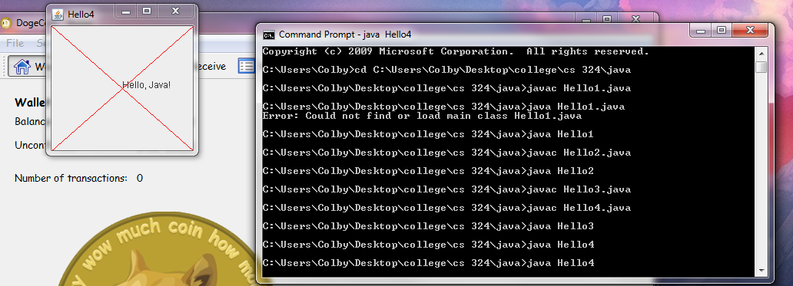Here’s a picture for proof: